[GitHub - gautriv/style.guide.io](https://github.com/gautriv/style.guide.io)

[Amazon Code Whisper](https://docs.aws.amazon.com/codewhisperer/latest/userguide/what-is-cwspr.html)

[THE SENSIBLE AI MANIFESTO](https://sensibleaimanifesto.com/)

**Plan for Technical Writers Embracing AI**

This plan aims to equip technical writers with the necessary skills to thrive in the evolving landscape of AI-powered content creation. It focuses on a gradual approach, starting with foundational understanding and progressing towards advanced applications.

**1. Foundational Understanding (3 Months):**

**AI Fundamentals:**

**Courses:**

**Coursera:** "AI for Everyone" by Andrew Ng

**Udacity:** "Intro to Artificial Intelligence"

**Khan Academy:** "Artificial Intelligence" course

**Books:** "Artificial Intelligence: A Modern Approach" by Stuart Russell and Peter Norvig

**Natural Language Processing (NLP):**

**Courses:**

**DeepLearning.AI:** "Natural Language Processing Specialization"

**Stanford CS224N:** "Natural Language Processing with Deep Learning"

**Books:** "Speech and Language Processing" by Dan Jurafsky and James H. Martin

**AI Tools for Technical Writing:**

**Explore:** Grammarly, QuillBot, Wordtune, Jasper, Copy.ai

**Understand:** Capabilities, limitations, and ethical implications.

**2. Practical Applications (6 Months):**

**AI-Assisted Content Creation:**

**Learn:** How to use AI tools for content generation, research, and editing.

**Practice:** Experiment with AI tools for your current writing tasks.

**Documenting AI Systems:**

**Develop:** Expertise in documenting AI models, algorithms, and data sets.

**Learn:** Best practices for explaining complex technical concepts in clear and concise language.

**Content Strategy with AI:**

**Analyze:** How AI can improve content planning, audience targeting, and personalization.

**Implement:** Strategies for leveraging AI to optimize content for various platforms and audiences.

**3. Advanced Skills (9 Months+):**

**AI-Powered Authoring Tools:**

**Master:** Advanced functionalities of AI writing tools for complex content creation.

**Explore:** Emerging technologies like GPT-3, LaMDA, and other large language models.

**AI for Technical Communication:**

**Develop:** Expertise in crafting AI-driven training materials, user manuals, and documentation.

**Explore:** How AI can be used for personalized learning experiences and adaptive knowledge management systems.

**AI Ethics and Responsible Use:**

**Understand:** Bias, fairness, transparency, and ethical considerations in AI-powered content creation.

**Advocate:** For responsible and ethical use of AI in technical communication.

**Career Progression:**

**Technical Writer with AI Expertise:** Expand your skills to become a valuable asset in AI-driven teams.

**AI Content Specialist:** Specialize in AI-powered content creation and strategy for businesses.

**AI Documentation Engineer:** Focus on documenting AI systems and creating user-friendly interfaces.

**AI Training and Support Specialist:** Design and develop training materials and support systems for AI products and services.

**Remember:**

**Continuously Learn:** The field of AI is constantly evolving, so stay up-to-date with the latest advancements.

**Experiment and Iterate:** Embrace a trial-and-error approach to find the best ways to leverage AI for your writing.

**Build Your Portfolio:** Showcase your AI skills and projects in your portfolio to demonstrate your expertise

[ttps://docs.rocketsoftware.com/bundle/mobius_ag_123/page/qck1695049554556.html](https://docs.rocketsoftware.com/bundle/mobius_ag_123/page/qck1695049554556.html)

•<https://docs.rocketsoftware.com/bundle/mobius_ag_123/page/dqp1690483386088.html>

•<https://docs.rocketsoftware.com/bundle/eo_442/page/kws1675435192007.html>

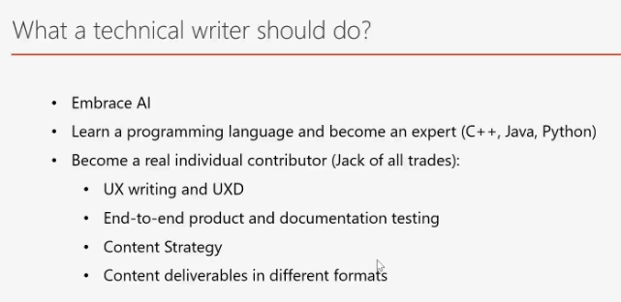

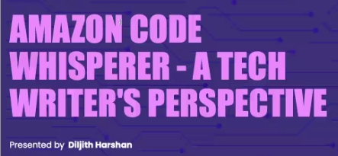

**For Naive Approach, copy the following sample prompt**👇

Hi ChatGPT, Write Functional Requirements for implementing Payment Gateway on my website.

**For  Persona Approach, copy the following sample prompt**👇

Hi ChatGPT, You are a documentation specialist. Write functional requirements for implementing Payment Gateway on the website

**For the Chain of Though Approach, copy the following sample prompt**👇

As a documentation specialist with 8 years of experience, your task is to generate functional requirements for integrating a payment gateway into my website.

Let's proceed step by step to outline the requirements:

When a user wants to make a payment, clicking on the call-to-action (CTA) button should redirect the user to the payment gateway page.

The user should be able to complete the payment process, and upon successful completion, a confirmation message should be displayed.

An appropriate error message should be shown in case of an error.

The payment gateway should support the preauthorization of card payments.

Prompt types to use effectively

* Classification prompts
* Reasoning prompts
* Completion prompts
* Creative prompts
* Comparison prompts
* Dialogue prompts
* Informational prompts
* Instructional prompts
* Interactive prompts
* Summarisation prompts
* Translation prompts

